WEEK-2 2520030182
P.VENKATA SRI SAI MADHURIMA

1.CREATE TABLE LOANS
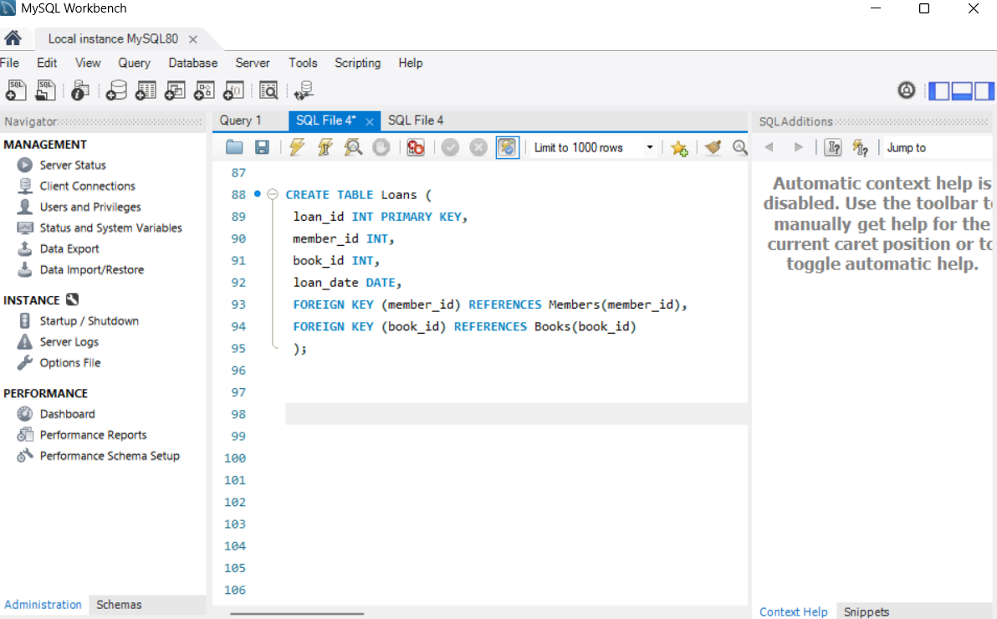

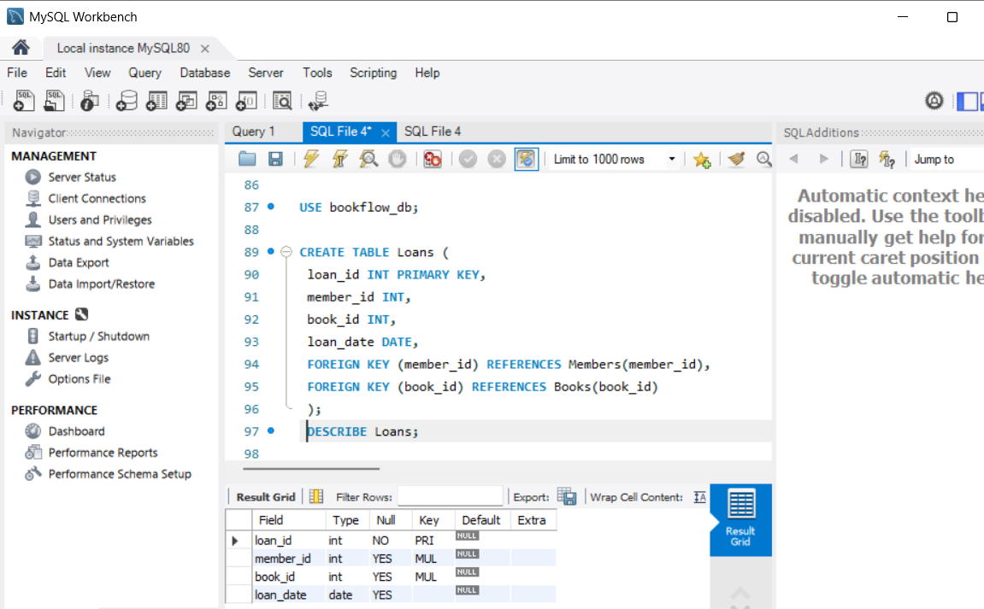

- Join Query
Combined two tabels
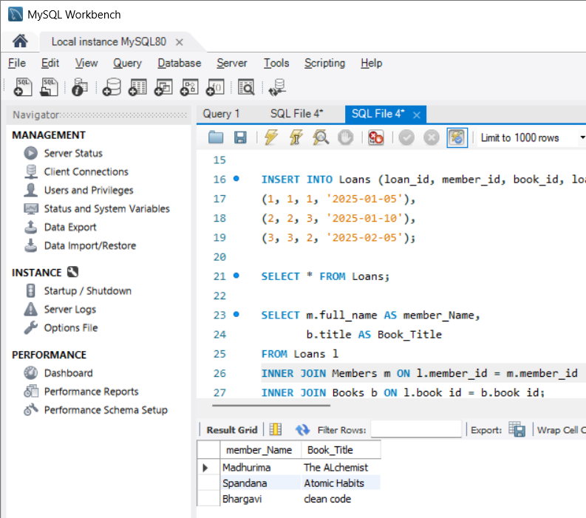

3.transaction

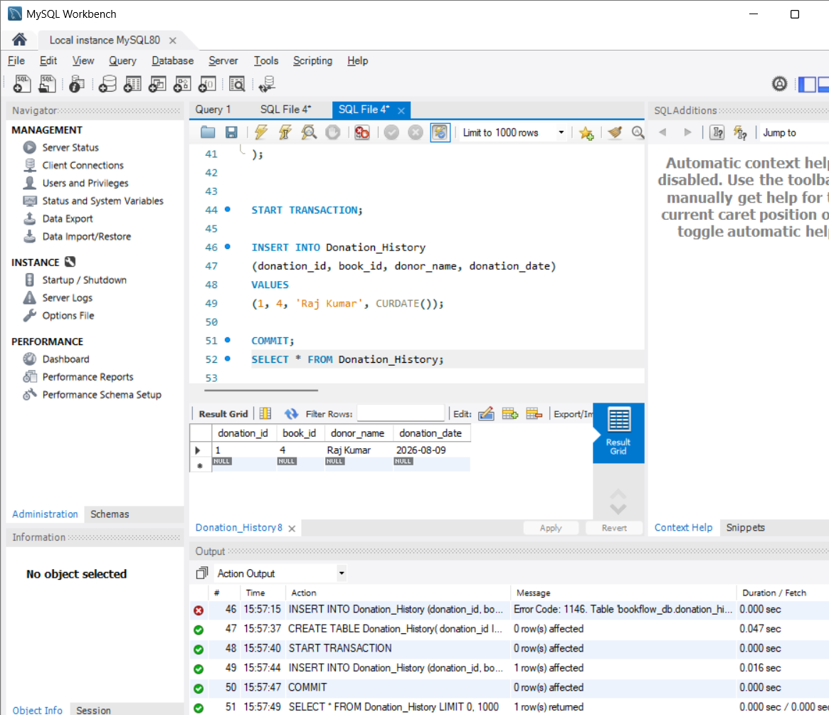

- Index on isbn from fast search
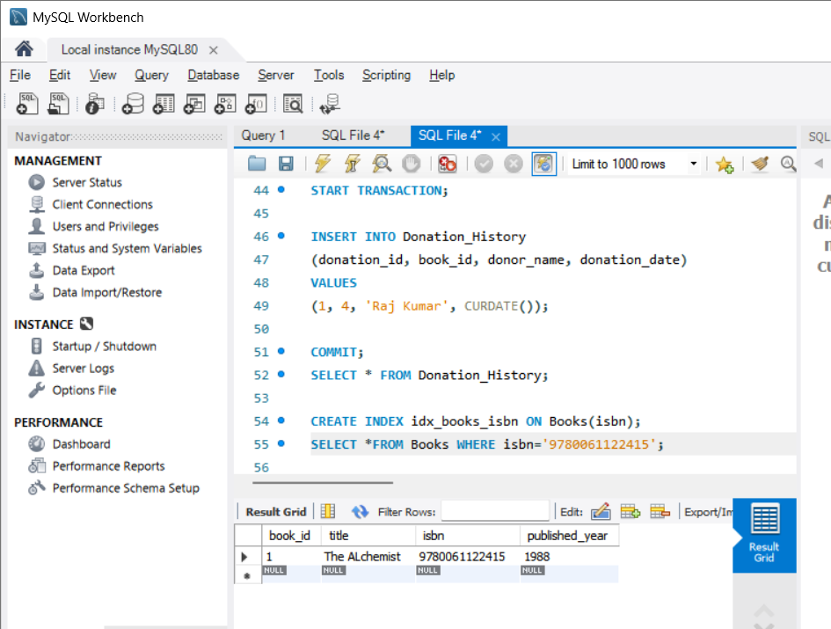

WEEK-2 COMPLETED
- VENKATA SRI SAI MADHURIMA
2520030182

